1. Programming Language
2. Technology
3. FrameWork
4. **Programming Language:-** Programming language is installable software. It provides basic features for developing application. It gives compiler/interpreter to check the syntax (rule)and semantic(Strucute) of the program. It is base for developing the OS,DB s/w, …etc.

**1.1.Terminology used in Programming Language:**

**1**. Source Code.

2. Compiler .

3. Compilation.

4. Interpreter.

5. Compile code.

6. Execution**.**

**7.** compiled PL.

8. Interpretered PL.

a) Source Code:- The code which is written by developer in any programming language is called source code. The code performs particular operation.

b) Compiler:- It is Translation program. The compiler translates source code into Machine Language code/Byte code **at once** and **at the time of compilation**. The compiler writes converted code in a new file.

Example:

1. The c compiler translates source code into Machine language code. It keeps machine language code in **.obj** file.

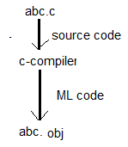

1. The Java compiler translates source code into byte code. This byte code can not be understood by os Because os knows only Machine language. Java compiler deposit byte code in **.class** file.

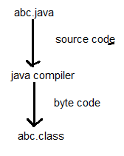

c) Interpreter:- It is translation program. It converts source into Machine Language code **line by line** and **at execution time**. The interpreter does not save the ML code in hard disk.

d) Compilation:- Converting/translating source code into Byte code/ML code is said to be compilation.

e) Compiled Code:- The code which is generated by compiler is compiled code(Byte code/ML code).

f) Compiled PL:- PL that uses compiler software for converting source code is compiled PL.

Example: c, c++

g) Interpreted PL:- PL that uses Interpreter software for converting source code is Interpreted PL.

Example: python, Java Script.

Note: Java , c#.net are compiled and interpreted Programming language.

1. **Technology:-** It is software specification providing set of rules and guide lines in the form of API to create implementation software using one or another programming languages. It is not installable software.

Technology API interfaces represents rules.

Technology API classes represents guidelines.

Technology API abstract class represents rules and guidelines.

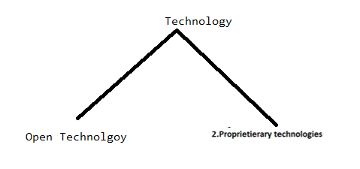

* 1. Open Technology:- If the technology designing vendor gives the rules and guide lines of the technology as open rules and guide lines for technology implementation vendor, then it is called as open technology.

Examples:- JDBC,Servlet,JSP,EJB,JPA,…etc.

Real time example:- open technology is like scientist keeping his formula in you tube channel at free of cost and allowing all vendors to create a product based on that formula.

* 1. Proprietierary Technology/closed Technology:- if technology design vendor only allowed to create implementation s/w based on rules and guide lines of his own technology then that technology is called “closed technology”.

Example:-

All .Net technologies are closed technologies.

1. **FrameWork:**-

Def1: Framework is special installable software. It is built on top of one or more technologies. It have ability to generate common logic of applications dynamically to make programmer to just write application specific logic.

The framework take help of technologies directly / Indirectly to generate the common logic.

Exaamples to Java Related Frameworks:

a.Structs

b.JSF

c.Hibernate

d.spring

e.spring Boot.

Advantages:-

1. In Technology based application, the programmer has to write both common logic and application specific logic. This is burden to programmer.

In framework based applications, the programmer need to write only application specific logic. Therefore framework simplifies application development.

1. Frame provides APIs. These APIs were created based on real time usecases.
2. It gives good productivity.(Doing more work in less time with good accuracy).

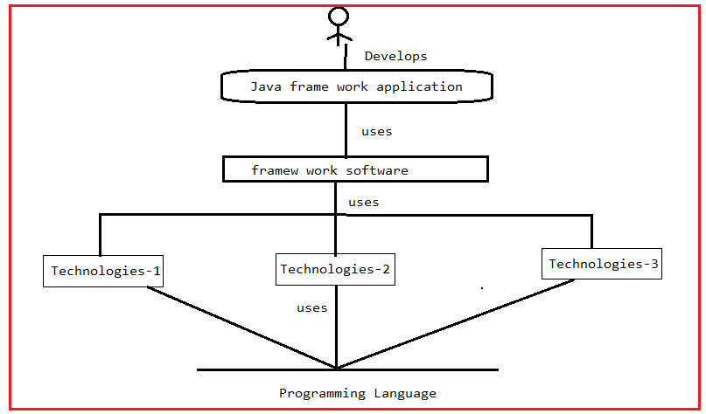

Developing the Applications using only Java-Language is like washing clothes using hand and soap.

Assumtion:Using language only, we complete project with in 200days.

Developing the Applications using technologies is like washing clothes using semi-automated washing machine.

Using Technology, we can complete same project with in 140 days.

Developing the Applications using frame work is like washing clothes using fully automated washing machine.

Using framework, we can complete same project with in 100days.

**Different kinds of Java frameworks based on kinds of application we develop:**

1. **Web application Frame work/MVC Frame works:-**These frameworks are built on servlet,JSP technology to simplify the MVC architecture based web applications.

Examples: sping MVC, spring Boot MVC, JSF(Java Server Faces), struts, web work.

1. **ORM Frame works:-** Provides an abstraction on JDBC technology to develop object based db software independent persistence logic as O-R (Object-Relation)mapping persistence logic (where 1 record will be mapped with one object of java class).

Example: hibernate , ibatis, eclipse link, top link , …etc.

**Spring ORM is not framework which internally uses other ORM Frame works.**

1. **JEE Frame works:-** This frame works provides the abstraction on java, JEE technologies like jdbc,servlet,jsp,jndi …etc to simplify the development of all kinds of applications(standard alone app, enterprise applications).

Example: spring ,spring Boot.

1. **Distributed Application Frameworks:**

RMI, CORBA, EJB are outdated technologies to develop the Distributed applications.

Web service is latest technology to develop the distributed applications in any language (JAVA,.NET..etc).

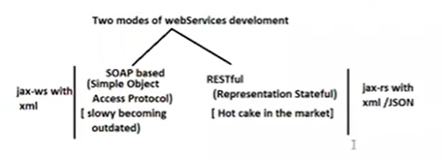

In web services environment , the data can be sent either in the form of xml or in the form of JSON .



Note:- Micro service is extension of Restful web services.

1. Big Data Frameworks:- The data that is beyond storing and processing capacity is called “BigData”.

Example to following application generates BigData:

1. Youtube Data
2. FB Data
3. Gmail data
4. OTT data …etc.

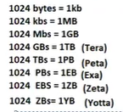

Example frameworks:-

Apache Hadoop, Apache Spark(100 times faster than Hadoop) Both are java based Big data frame works.

**Based on types of Programming, Kinds of Java Frame works**

1. Invasive Java Frameworks.

2. Non-Invasive Java Frameworks.

**1.Invasive Java FrameWorks:-** The classes of application should implement /extend the Framework API interfaces/classes. There is tightly coupling between App and Invasive java Frameworks.

Real Example:- Marriage kind of life commitment.

The classes of application can not be used in another frame works because they are bound with invasive frame works.

Example: structs 1.x are only invasive java frame works . Remaing versions are non-invasive Java frame works.

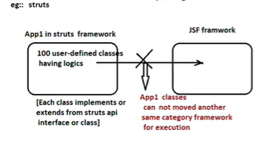

**2.Non-Invasive Java Frame works**:- The classes of application does not need to implement/extend the framework API interfaces/classes. There is loosely coupling between application and Non-Invasive Java Frame works.

Real Time Example:- Boy and girl in relation.

The classes of application can be used in another frame works because they are bound with invasive frame works.

Example:- spring,hibernate,jsf …etc.

